

**ECE 387**

**Final Project Written Proposal**

**Ryan Gracia-Rodriguez**

***Department of Computer and Electrical Engineering***

***College of Engineering and Computing, Miami University, Oxford, OH, 45056***

**Professor: Dr. Jamieson**

**28 March 2021**

## 

## Project Overview

Inspired by the popular game Among Us created by InnerSloth LLC I plan on making a physical version of the Simon Says task. One of the victory states of the games is for the players designated as crew to complete a number of tasks, such as Simon Says, before they are stopped by the traitor/traitors. The task consists of a 3x3 grid of buttons. A display indicates what order the buttons need to be pressed. If the buttons are pressed in the correct order the player advances to the next level. Once the player completes 5 levels without failure the task is completed.

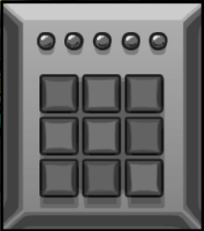

***Figure 1:***Simon Says from Among US

## Main Objectives

I plan on replicating the keypad and Simon Says features from the game. The keypad will have 9 keys which will light up in the order they need to be pressed. Each level will have a randomized sequence of buttons the user needs to input. As Puzzles are completed successfully, the indicator lights will turn green to show the number of puzzles completed. If a button is pressed incorrectly, the lights will flash red and the score will be cleared.

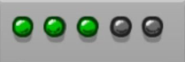

***Figure 2:*** Three Puzzles completed

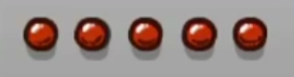

***Figure 3:*** Puzzle Failed

## Additional Features

In the game, there are two units for the task. One display shows which order the buttons need to be pressed in and keeps track of the score, the other is for user input. If I have time I plan on implementing this second display unit that will wirelessly connect to the main unit.

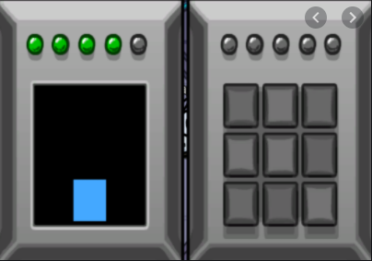

***Figure 4:*** Two Unit Simon Says